Mudpuppy - 2022

Minnesota’s largest, fully aquatic salamander. Often, they are referred to as ‘bio-indicators’ because they are sensitive to pollutants and water quality. These salamanders act as an early warning system for environmental problems.

Mudpuppies are unusual among amphibians because they live their entire lives underwater and never go through metamorphosis. Animals that retain their larval features into adulthood are called neotenic. Mudpuppies are sometimes confused with axolotls, which are also neotenic salamanders.

Mudpuppies get their name from the squeaky sound they make when they’re out of the water, which some people think sounds like a dog’s bark.

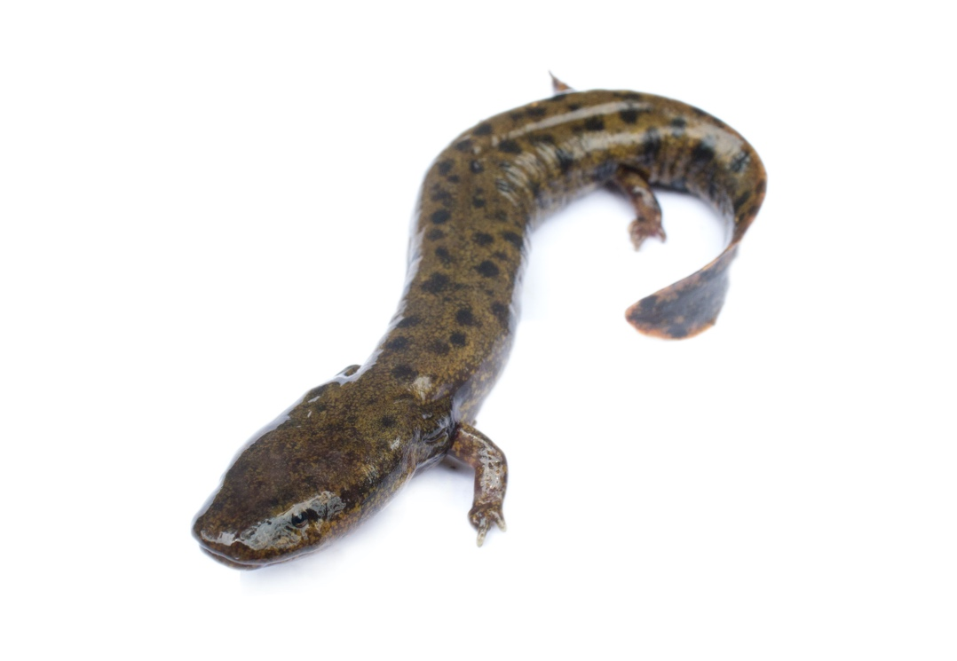

DNR - We have received many reports of dead mudpuppies from Lake Carlos this year. These die-offs have occurred periodically since 2012 in certain lakes between Detroit Lakes and Alexandria, Lake Carlos being one of them. The USGS has been studying the phenomenon but no clear answers have been reached. The good news is that it appears the die-offs only happen as the water temperatures rise in June and early July. After that, we do not see as many washing up on shorelines. If you happen to find one that is still alive but appears to be sick, please let me know. Amphibians decay very quickly after death, so it has been difficult to get fresh specimens for testing.

Alex Letvin
Glenwood Area Fisheries Supervisor
Minnesota Department of Natural Resources
23070 North Lakeshore Drive
Glenwood, MN 56334
Phone: 320-634-7323
Email: Alexander.Letvin@state.mn.us

